|  |
| --- |
| **LAB 1** |

**IMPLEMENTATION OF BASIC COMBINATION LOGIC CIRCUIT USING VERILOG**

Phạm Quang Vinh ITITIU21347

### II.1 LAB EXPERIMENT 1 : WRITE HDL CODE TO REALIZE ALL LOGIC GATES

**// data flow**

module lab1_ex1(SW,LEDG,LEDR);

input[17:0] SW;

output[7:0] LEDG;

output[17:0] LEDR;

assign LEDR=SW;

allgate_DF DUT(.a(SW[1]),.b(SW[0]),.yand(LEDG[6]),.yor(LEDG[5]),.ynot(LEDG[4]),.ynand(LEDG[3]),.ynor(LEDG[2]),.yxor(LEDG[1]),.yxnor(LEDG[0]));

endmodule

module allgate_DF ( a, b, yand,yor,ynot,ynand,ynor,yxor,yxnor );

input a,b;

output yand, yor, ynot, ynand, ynor, yxor, yxnor;

assign yand = a & b; // AND Operation

assign yor = a | b; // OR Operation

assign ynot = ~a ; // NOT Operation

assign ynand = ~(a & b); // NAND Operation

assign ynor = ~(a | b); //NOR Operation

assign yxor = a ^ b; //XOR Operation

assign yxnor =~(a^b); //XNOR Operation

endmodule  
 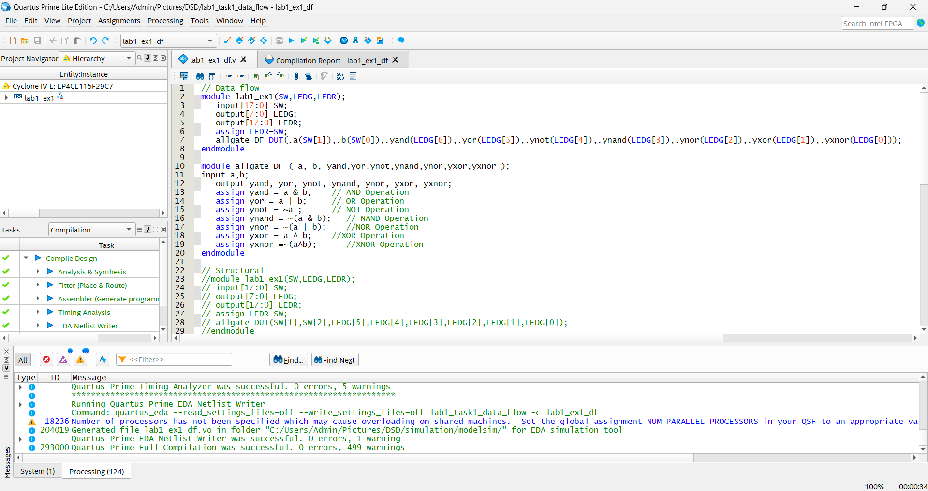

**// Structural**

module lab1_ex1(SW,LEDG,LEDR);

input[17:0] SW;

output[7:0] LEDG;

output[17:0] LEDR;

assign LEDR=SW;

allgate DUT(SW[1],SW[2],LEDG[5],LEDG[4],LEDG[3],LEDG[2],LEDG[1],LEDG[0]);

endmodule

module allgate ( a, b, yand,yor,ynot,ynand,ynor,yxor,yxnor );

input a,b;

output yand, yor, ynot, ynand, ynor, yxor, yxnor;

assign yand = a & b; // AND Operation

assign yor = a | b; // OR Operation

assign ynot = ~a ; // NOT Operation

assign ynand = ~(a & b); // NAND Operation

assign ynor = ~(a | b); //NOR Operation

assign yxor = a ^ b; //XOR Operation

assign yxnor =~(a^b); //XNOR Operation

endmodule

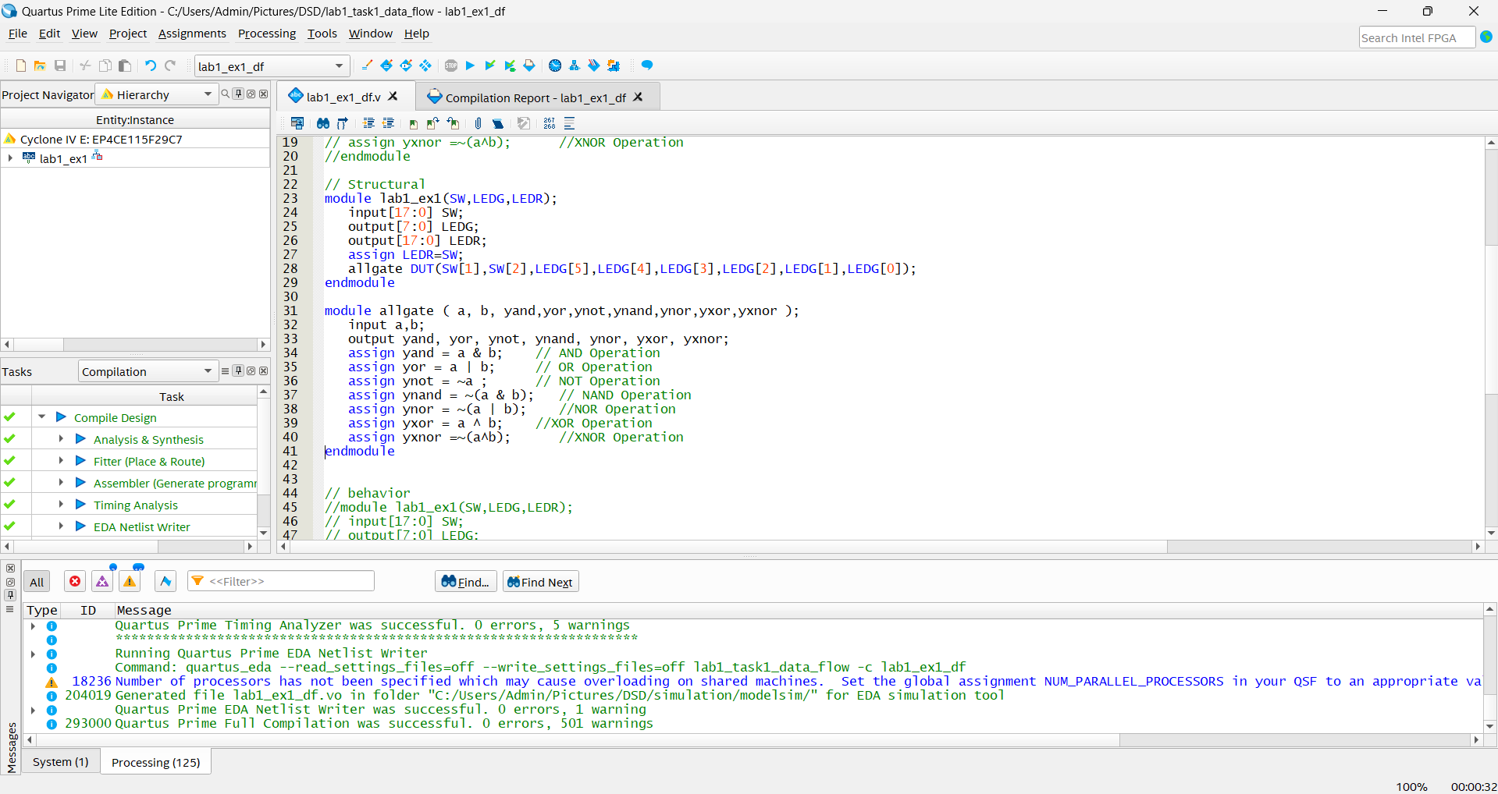

**// behavior**

module lab1_ex1(SW,LEDG,LEDR);

input[17:0] SW;

output[7:0] LEDG;

output[17:0] LEDR;

assign LEDR=SW;

allgate_BH DUT(SW[1],SW[2],LEDG[5],LEDG[4],LEDG[3],LEDG[2],LEDG[1],LEDG[0]);

endmodule

module allgate_BH ( a, b, yand,yor,ynot,ynand,ynor,yxor,yxnor );

input a,b;

output yand, yor, ynot, ynand, ynor, yxor, yxnor;

reg yand, yor, ynot, ynand, ynor, yxor, yxnor;

always @(*)

begin

yand = a & b; // AND Operation

yor = a | b; // OR Operation

ynot = ~a ; // NOT Operation

ynand = ~(a & b); // NAND Operation

ynor = ~(a | b); //NOR Operation

yxor = a ^ b; //XOR Operation

yxnor =~(a^b); //XNOR Operation

end

endmodule

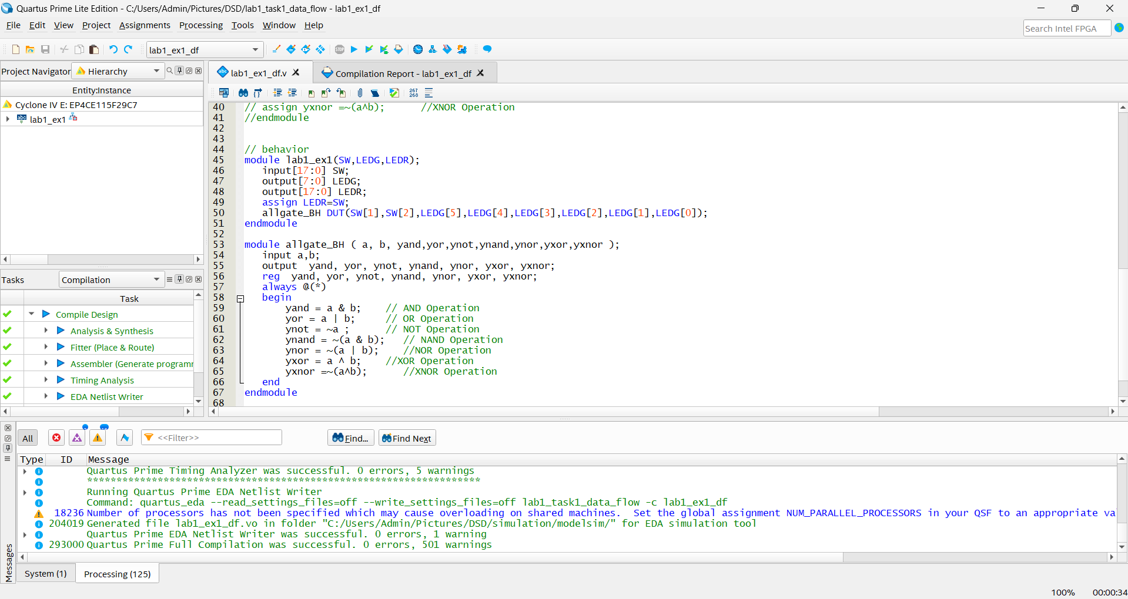

**II.2 LAB EXPERIMENT 2 : WRITE VERILOG HDL CODES TO SIMULATE AND IMPLEMENT THE HALF ADDER CIRCUIT:**

**// Structural**

module Lab1_task2_STRUC(SW,LEDR,LEDG);

input[0:17] SW;

output[0:7] LEDR;

output[0:17] LEDG;

assign LEDG=SW;

half_adder_structeral DUT(.a(SW[0]),.b(SW[1]),.s(LEDR[0]),.Cout(LEDR[1]));

endmodule

module half_adder_structeral(input a, b, output s, Cout);

xor G1(s,a,b);

and G2(Cout,a,b);

endmodule  
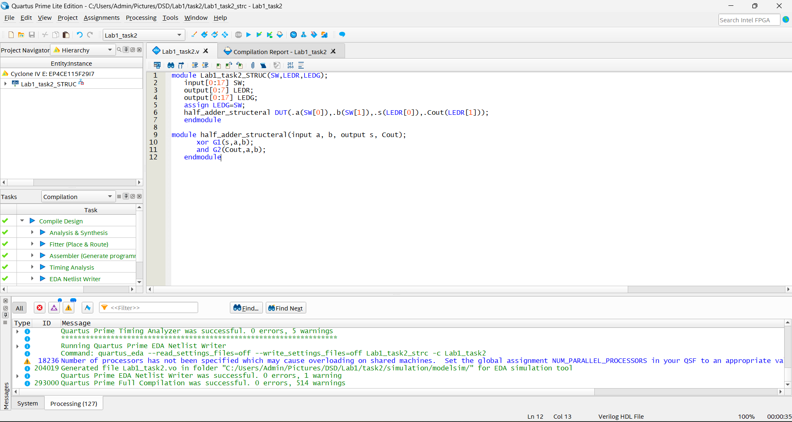

**// data flow**

module Lab1_task2(SW,LEDR,LEDG);

input[0:17] SW;

output[0:7] LEDR;

output[0:17] LEDG;

assign LEDG=SW;

half_adder_dataflow DUT(.a(SW[0]),.b(SW[1]),.s(LEDR[0]),.Cout(LEDR[1]));

endmodule

module half_adder_dataflow(input a, b, output s, Cout);

assign s = a ^ b;

assign Cout = a & b;

endmodule  
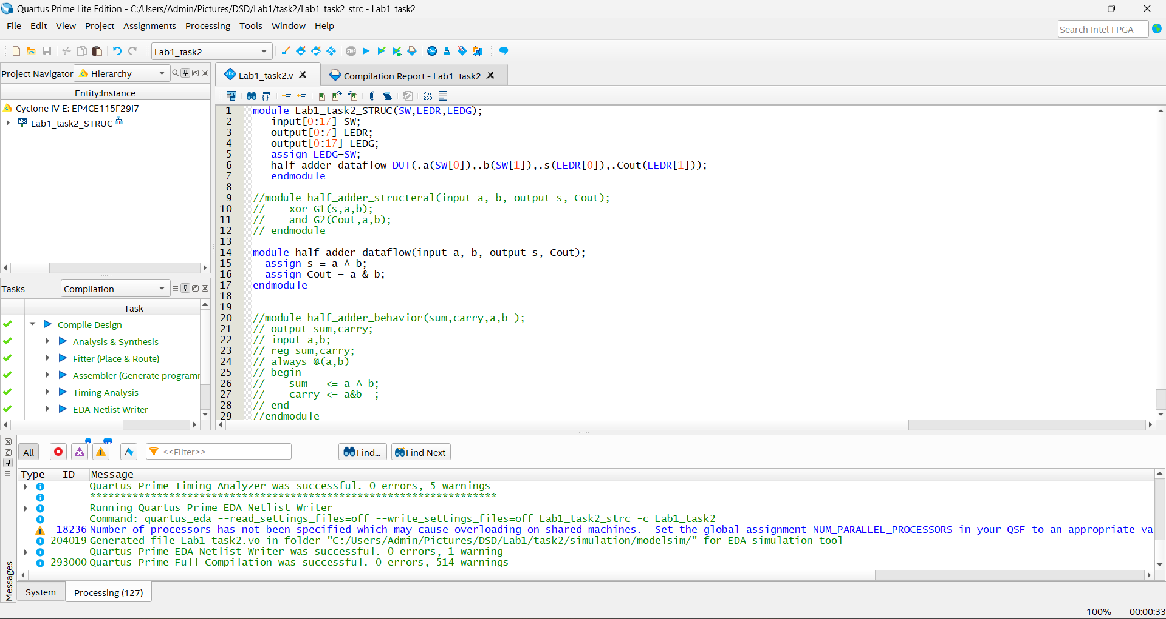

// **Behavior**module Lab1_task2(SW,LEDR,LEDG);

input[0:17] SW;

output[0:7] LEDR;

output[0:17] LEDG;

assign LEDG=SW;

half_adder_behavior DUT(.a(SW[0]),.b(SW[1]),.sum(LEDR[0]),.carry(LEDR[1]));

endmodule

module half_adder_behavior(sum,carry,a,b );

output sum,carry;

input a,b;

reg sum,carry;

always @(a,b)

begin

sum <= a ^ b;

carry <= a&b ;

end

endmodule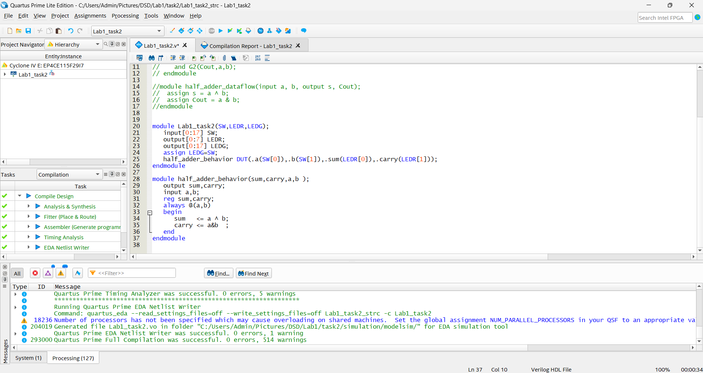

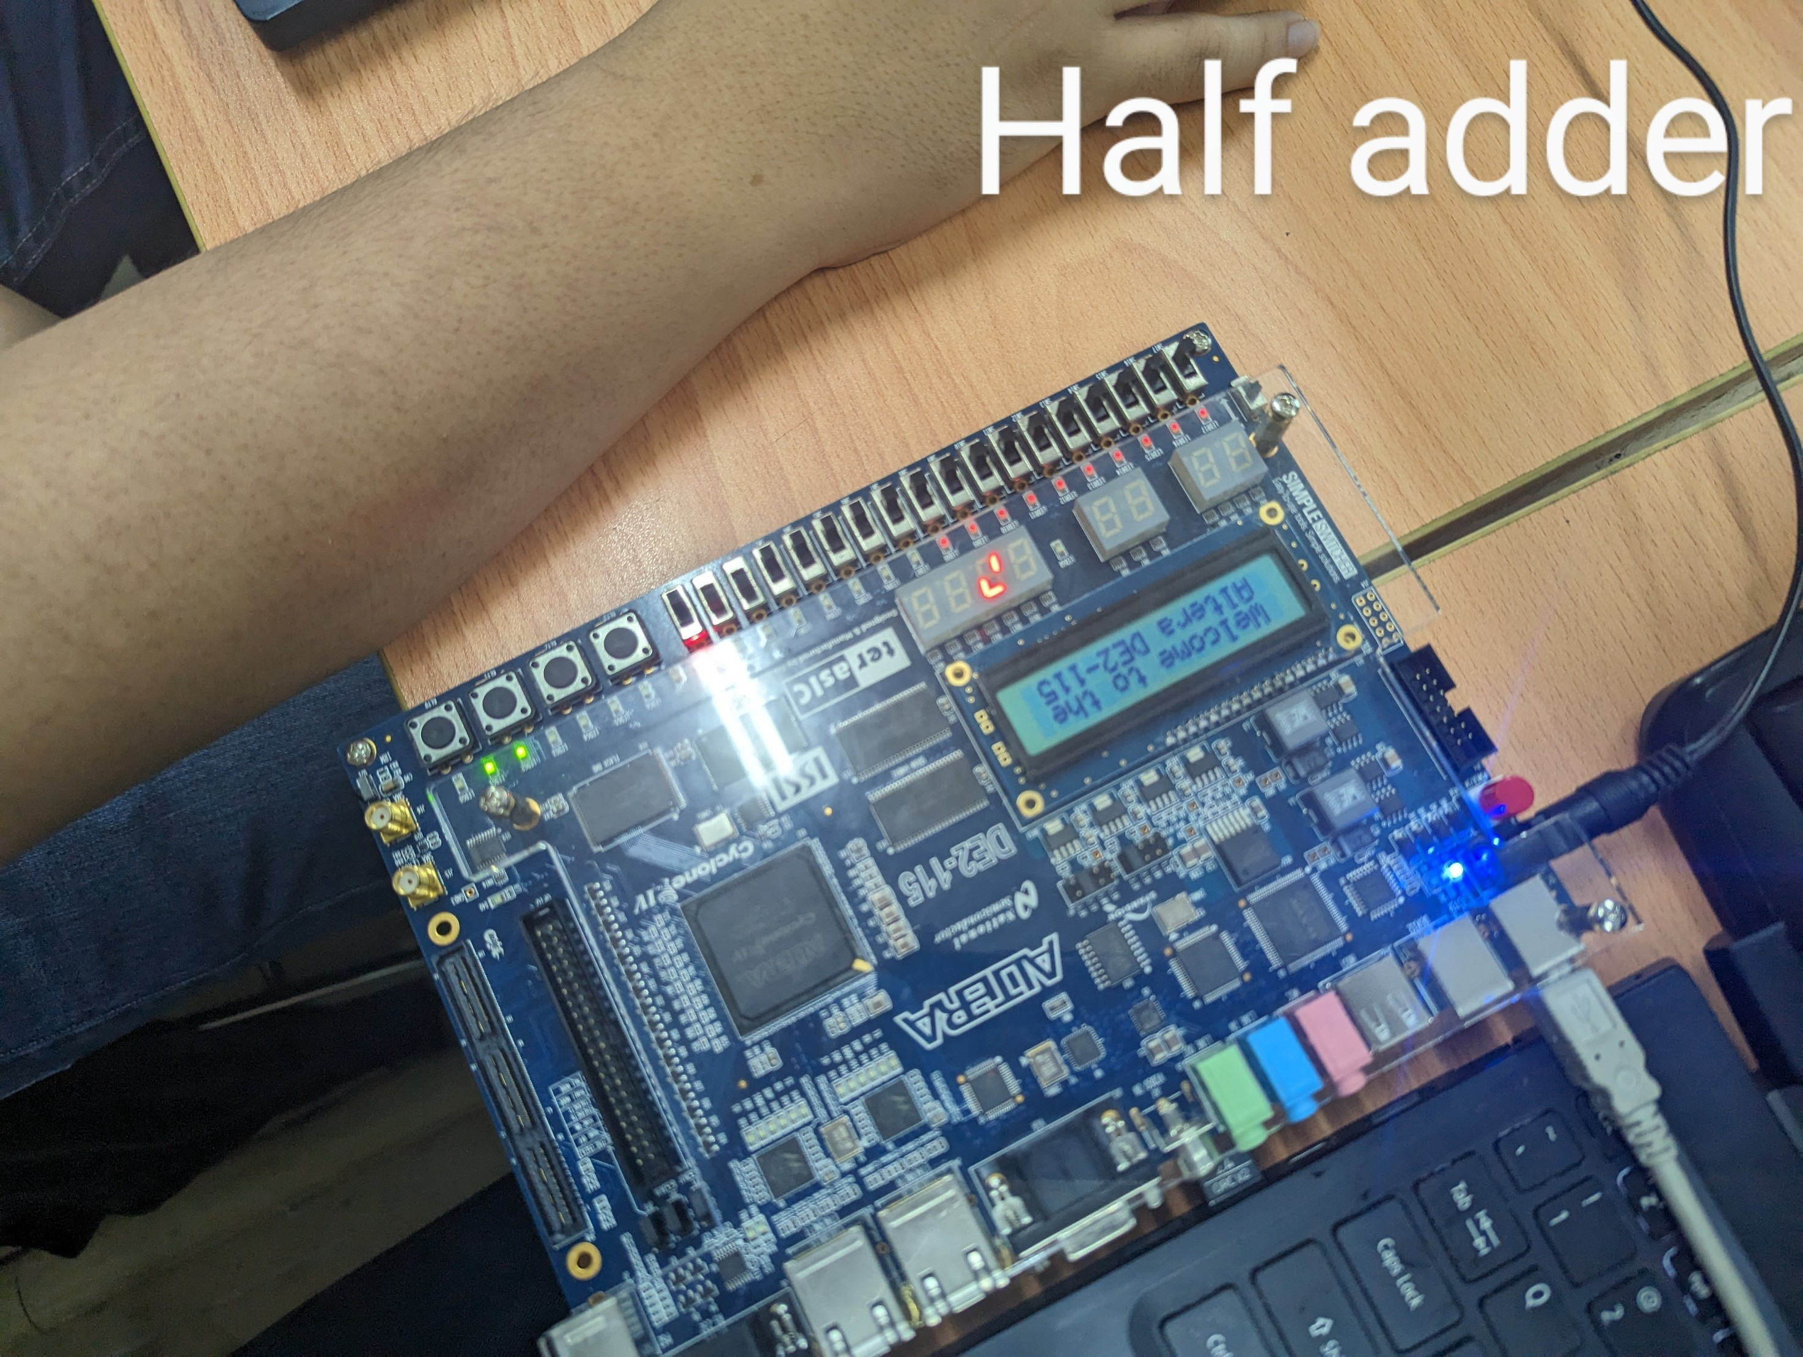

**II.3 EXPERIMENT 3: WRITE VERILOG HDL CODES TO SIMULATE AND IMPLEMENT THE FULL ADDER CIRCUIT:**

**// dataflow**

module Lab1_task3(SW,LEDG,LEDR);

input[17:0] SW;

output[7:0] LEDG;

output[17:0] LEDR;

assign LEDR= SW;

full_adder_DTFL DUT(SW[2],SW[1],SW[0],LEDG[1],LEDG[0]);

endmodule

module full_adder_DTFL(input a, b, c, output Sum, Cout);

assign Sum= a ^ b ^ c;

assign Cout= (a&b)|(b&c)|(a&c);

endmodule

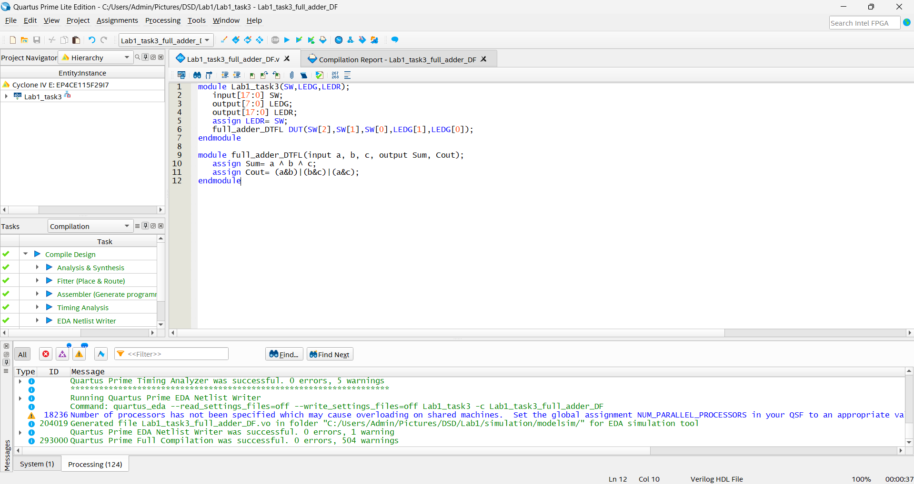

// **Structural**

module Lab1_task3(SW,LEDG,LEDR);

input[17:0] SW;

output[7:0] LEDG;

output[17:0] LEDR;

assign LEDR= SW;

full_adder_STRU DUT(SW[2],SW[1],SW[0],LEDG[1],LEDG[0]);

endmodule

module full_adder_STRU(A,B,Cin,Sum,Carry);

output Sum,Carry;

input A,B,Cin;

wire x,y,z;

xor g1(x,A,B);

xor g2(Sum,x,Cin);

and g3(y,x,Cin);

and g4(z,A,B);

or g5(Carry,x,y);

endmodule

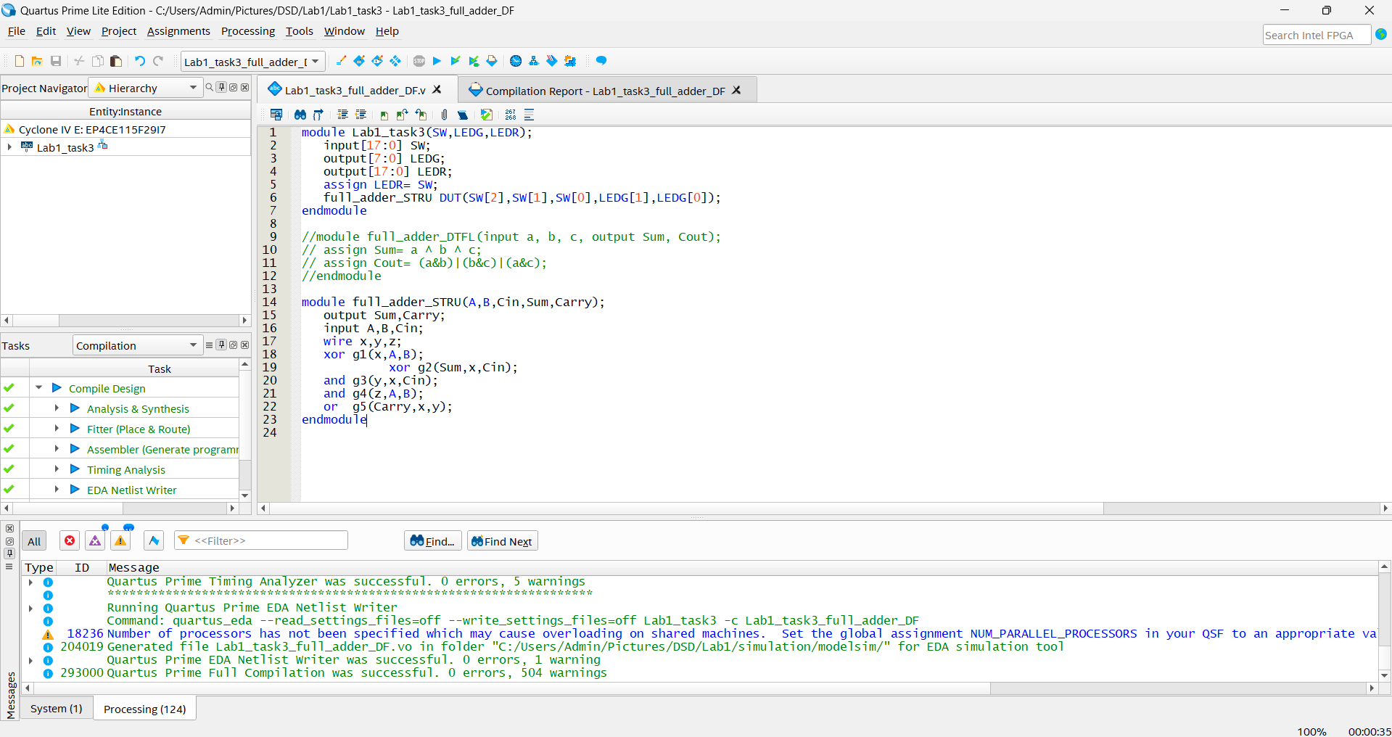

**// Behavior**

module Lab1_task3(SW,LEDG,LEDR);

input[17:0] SW;

output[7:0] LEDG;

output[17:0] LEDR;

assign LEDR= SW;

full_adder_BH DUT(SW[2],SW[1],SW[0],LEDG[1],LEDG[0]);

endmodule

module full_adder_BH(a,b,c,sum,carry);

output sum,carry;

input a,b,c;

reg sum,carry;

always @ (a,b,c)

begin

sum <= a^ b^c;

carry <=(a&b) | (b&c) | (c&a);

end

endmodule

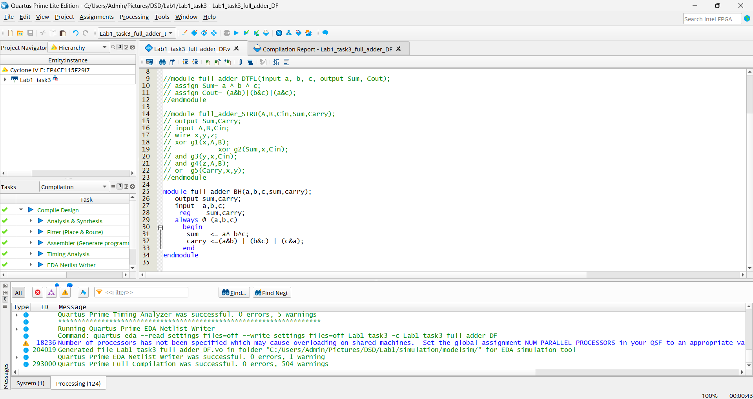

module Lab1_task3(SW,LEDG,LEDR);

input[17:0] SW;

output[7:0] LEDG;

output[17:0] LEDR;

assign LEDR= SW;

full_adder DUT(SW[2],SW[1],SW[0],LEDG[1],LEDG[0]);

endmodule

module full_adder( A, B, Cin, S, Cout);

input wire A, B, Cin;

output reg S, Cout;

always @(A or B or Cin)

begin

if(A==0 && B==0 && Cin==0)

begin

S=0;

Cout=0;

end

else if(A==0 && B==0 && Cin==1)

begin

S=1;

Cout=0;

end

else if(A==0 && B==1 && Cin==0)

begin

S=1;

Cout=0;

end

else if(A==0 && B==1 && Cin==1)

begin

S=0;

Cout=1;

end

else if(A==1 && B==0 && Cin==0)

begin

S=1;

Cout=0;

end

else if(A==1 && B==0 && Cin==1)

begin

S=0;

Cout=1;

end

else if(A==1 && B==1 && Cin==0)

begin

S=0;

Cout=1;

end

else if(A==1 && B==1 && Cin==1)

begin

S=1;

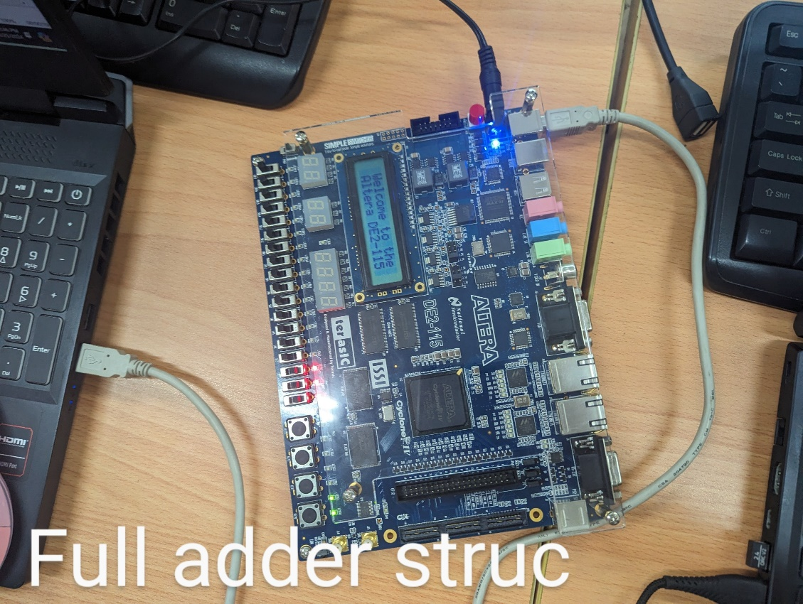 Cout=1;

end

end

endmodule

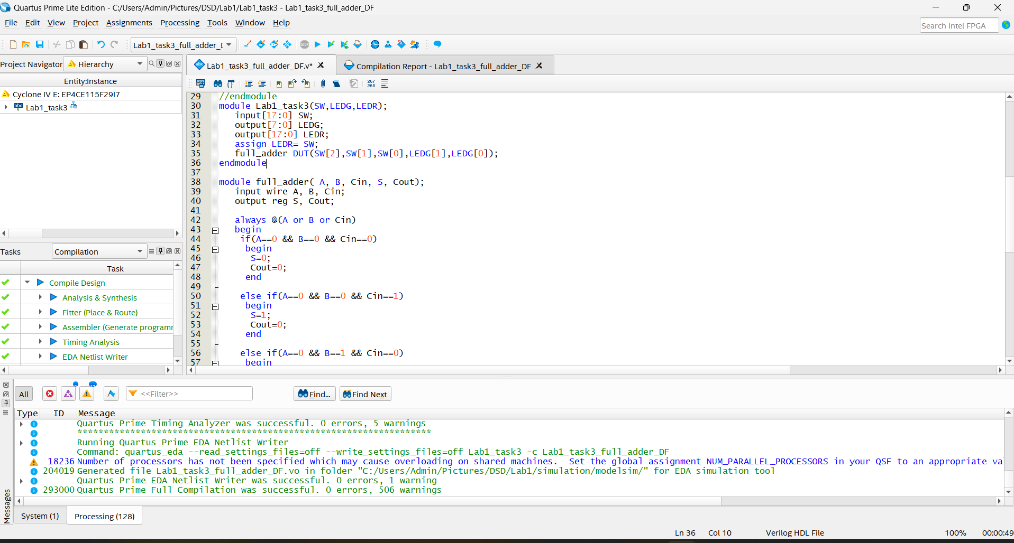

EXTRA

module Lab1_extra_1(SW,LEDR,LEDG);

input [17:0] SW;

output [17:0] LEDR;

output [0:7] LEDG;

assign LEDR=SW;

mux81str DUT(.i0(SW[0]),.i1(SW[1]),.i2(SW[2]),.i3(SW[3]),.i4(SW[4]),.i5(SW[5]),.i6(SW[6]),.i7(SW[7]),.s0(SW[8]),.s1(SW[9]),.s2(SW[10]),.y(LEDG[0]));

endmodule

module mux81str(i0,i1,i2,i3,i4,i5,i6,i7,s0,s1,s2,y);

input i0,i1,i2,i3,i4,i5,i6,i7,s0,s1,s2;

output y;

wire a,b,c,d,e,f,g,h,n_s0,n_s1,n_s2;

not N0(n_s0,s0);

not N1(n_s1,s1);

not N2(n_s2,s2);

and G0(a,i0, n_s2, n_s1, n_s0);

and G1(b,i1, n_s2, n_s1, s0);

and G2(c,i2, n_s2, s1, n_s0);

and G3(d,i3, n_s2, s1, s0);

and G4(e,i4, s2, n_s1, n_s0);

and G5(f,i5, s2, n_s1, s0);

and G6(g,i6, s2, s1, n_s0);

and G7(h,i7, s2, s1, s0);

or G8(y,a,b,c,d,e,f,g,h);

endmodule  
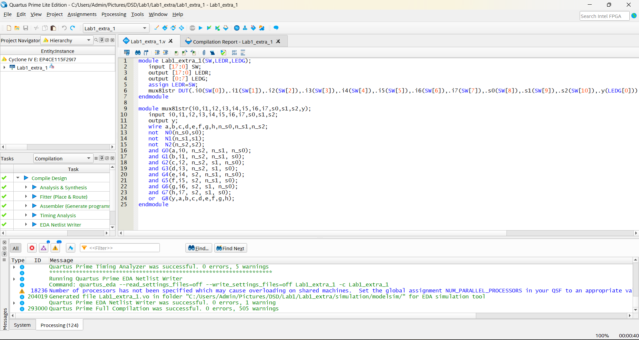

**Extra 1a**

module lab1_extra_ex1a(SW,LEDR,LEDG);

input [17:0] SW;

output [17:0] LEDR;

output LEDG;

assign LEDR=SW;

modulemux81str DUT(.i(S[10:3]),.s(SW[2:0]).y(LEDG[0]));

endmodule

modulemux81str(i,s,y);

input [7:0] i;

input [2:0] s;

output y;

wire [7:0] out_and;

wire [2:0] n_s;

;

not N0(n_s[0],s[0]);

not N1(n_s[1],s[1]);

not N2(n_s[2],s[2]);

and G0(out_and[0],i[0], n_s[2], n_s[1], n_s[0]);

and G1(out_and[1],i[1], n_s[2], n_s[1], s[0]);

and G2(out_and[2],i[2], n_s[2], s[1], n_s[0]);

and G3(out_and[3],i[3], n_s[2], s[1], s[0]);

and G4(out_and[4],i[4], s[2], n_s[1], n_s[0]);

and G5(out_and[5],i[5], s[2], n_s[1], s[0]);

and G6(out_and[6],i[6], s[2], s[1], n_s[0]);

and G7(out_and[7],i[7], s[2], s[1], s[0]);

or G8(y,out_and[7:0]);

endmodule

